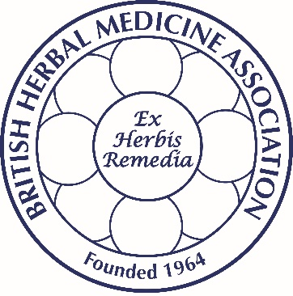

British Herbal Medicine Association
Public Statement

The BBC website (http://www.bbc.co.uk/news/health-38495088 - 3 January 2017) reports on a warning given by doctors about the dangers of New Year detoxes. The story highlights the case of a 47yr old woman who required treatment in an intensive care unit last year after drinking too much water, and taking a variety of herbs contained in herbal food supplements. The woman fully recovered after treatment.

Chairman of the BHMA, Dr Dick Middleton, noted that there are no THR herbal medicines available for “detox”, which is a marketing rather than a medical type of terminology. He commented that whilst some herbal products are used to maintain health and are sold as herbal food supplements, herbal remedies are regulated and sold as medicines and should be treated with care and taken appropriately. Any person who wishes to use an herbal medicine, often to treat minor ailments, should purchase one that displays the THR logo on the packaging. The THR logo shows that the herbal medicine has been approved by the UK Licensing Authority, the Medicines and Healthcare Products Regulatory Authority (MHRA) and is of assured quality. Reading the approved patient information leaflet inside the pack will explain whether the herbal medicine is appropriate to take and how to take it safely.

Dr Middleton further commented that “because THR herbal medicines are regulated by the MHRA, and their quality is reviewed on an ongoing basis, consumers can have confidence that THR products are of the highest quality and can be used safely where appropriate. If in doubt or if you are taking any medicines or have any pre-existing medical conditions, always consult your GP.”

- Ends -

Press enquiries or to speak to a BHMA spokesperson, contact Michelle Redmond, Minx PR, 07734 681796 / michelle@minxpr.com

